Life Lessons Learned

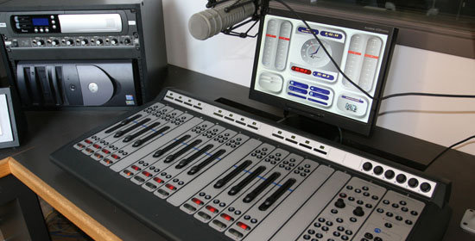

A podcast giving people a chance to tell their story and for their lessons to be heard.

Table of Contents

**This writing piece is an interviewed based project called Life Lessons Learned. It’s an in-depth podcast analyzing three interviewees, who share their lessons through storytelling.

Introduction
What are Life Lessons Learned? How did it come to pass? Why make a podcast about people telling their stories? – Introductory Statement

Body
Step by step process of pre-production, production, and post-production. Overview of all three interviewees so far.

Conclusion
What did I learn? – Conclusion Statement

"Overall, I hope that this podcast influences people to make good choices. After all, isn't that what success is—making good choices and improving the quality of our lives?"

Introductory Statement

Everyone has a story to tell. In the words of a BYU-Idaho professor, Eric Embree, Communication 273 — Professional Presentations: "One of the most important lessons I've learned in life is that everyone has a voice…Everyone has a useful message that can benefit others." Embree learned this lesson after he made a life-changing choice to join his high school debate team. People telling stories and communicating life lessons, just like the example above, is the basis of my podcast.

What are Life Lessons Learned? It is a podcast designed for persons to tell their stories and for their lessons to be heard. All interviewees chosen served LDS missions and are members of the LDS church, which made it comfortable to speak openly about religious beliefs. Listening to the interviewees' talk about important societal subjects should inspire the listeners to contemplate their life choices. Life Lesson Learned is a good podcast because it highlights what matters in life—missionary work, college education, career endeavors, and family relationships.

How did it come to pass? The first person I interviewed, Matthew Treter, helped me come up with the idea. The idea came from a desire to fulfill an assignment but quickly turned into an opportunity to talk with others on a real level. It took some time to refine it. However, the result is powerful yet simple. Although naming the podcast took time, I thought the name and the idea were great. Perhaps Donald J. Trump, currently running for president of the United States, says it best—"Belief in product value strongly influences its success." I feel confident that the podcast will be beneficial.

Why make a podcast about people telling their stories? The lessons shared herein will benefit people in numerous ways. They can help people avoid unnecessary suffering. Healthier relationships, learning and applying valuable information, and being a more productive member of society are just a few ideas this podcast promotes. In short, these stories and lessons will strengthen the listener’s morality.

As stated in the table of contents, this document will go through some of the necessary steps of making the podcast, interviewing the interviewees, and a conclusion statement that describes what I learned from the experience. Overall, I hope that this podcast influences people to make good choices. After all, isn't that what success is—making good choices and improving the quality of our lives?

Pre-Production—Preparation

Establish contact with the individual(s) and set up a time:

I found, talked, and asked all three interviewees to interview with me. They agreed to set places and established times. I interview two out of the three interviews at the BYU-Idaho radio station.

Any Extended Research Required?

Because I knew all interviewees, I knew their necessary information. I knew where they were from, their hobbies, and where they served their LDS missions. I also knew Myles and Lauran were both married. However, I still felt the need to ask them more questions in preparation for the interviews.

Prepare Questions:

By definition, questions are carefully worded statements designed to acquire information. I felt like I asked the right questions. Good interviews have a series of well-thought-out questions that carefully extract new and vital information so that the listener can be informed and possibly entertained. Asking the right questions to build off each other leads towards a meaningful conversation, as well. The beginning questions were simple, while the latter questions were more complex and dynamic.

**Halfway through the podcast, I asked the central question: what is the story you want to share so others can benefit from your life lesson learned?

Gather Materials:

Most of the materials needed for the interview were already at the radio station. I brought notebook paper, writing utensils, and printed paper with the questions I needed to ask. Matthew was kind enough to lend me his audio recorder for his interview.

Production—The Interview Itself

The actual interview is the most crucial part of this process. Here are several methods I implemented to give the interview balance and validity:

Start Casual:

The best meetings begin with a casual conversation. I asked the interviewee basic questions like where you are from and where did you serve your mission. I felt like this reduced nervous pressure and made it easier for both the interviewer and interviewee.

Take Notes:

While I took notes, I tried to keep eye contact with the interviewees. Maintaining eye contact was easy because I knew all three interviewees well. As such, I didn't have to take too many notes. Besides, if the interviewer knows the interviewee well things are less awkward, and the interview runs more smoothly.

Be Observant:

Much of interviewing is using our senses to observe the person speaking. In the case of being the interviewer, it's the words, especially the individual words that need to be understood. Good interviewers observe well, but they also can take important words and ask the interviewee to expound on them, which brings added understanding. I thought I did this well during crucial points in the interview.

Stay in Control of the Situation:

The purpose of the podcast is to provide background information, telling a story or two and the lessons the interviewee has learned. While there are many other elements to the podcast, keeping the conversation on track is essential. Fortunately, all my interviewees understood this and lived up to the expectations.

Digest the Information:

I listened to the raw audio clips and tried to understand the presented information. Although there are advantages to video over audio, professionals generally believe that sound is more important than video. Research studies show that audio causes people to focus on spoken words rather than focusing on the visuals. The neat thing about digesting the presented information after it, the fact is that it becomes easier to understand as the podcast progresses.

Post-Production—The Process of Refinement
What you are looking at is the first step in the post-production process. It is inserting the raw audio recorded clip into the Adobe Audition program. At this point, it would be essential to listen to the entire interview, so you know what to keep and what to edit.

STEP # 1

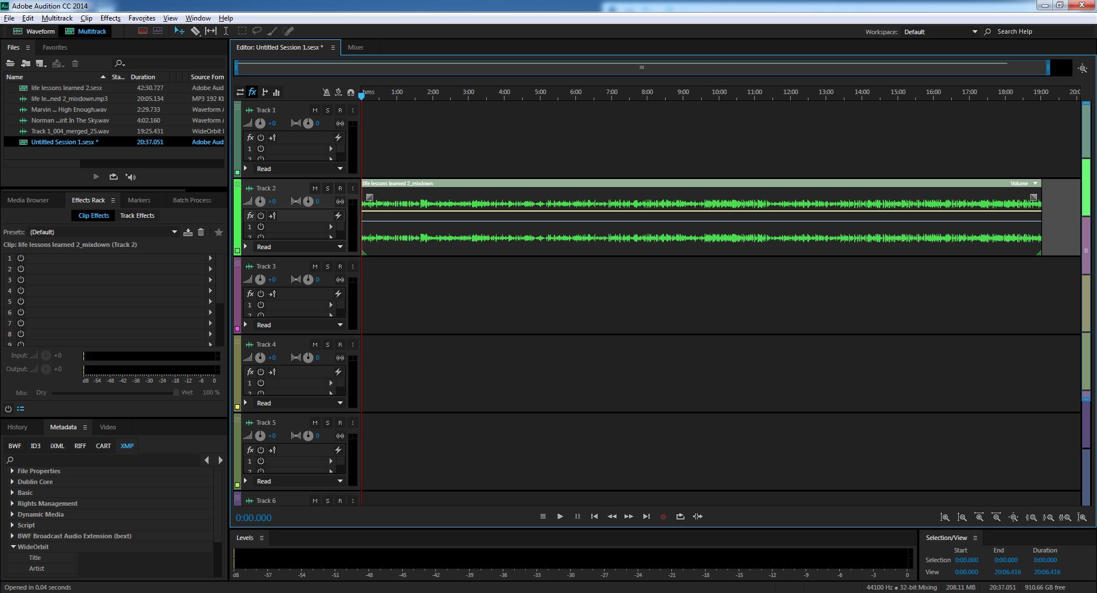

The second screenshot is depicting cutting out the unnecessary parts of the interview and putting the original audio in the top row while the bottom row clips may be deleted or saved for a rainy day. Believe it or not, this is the most time-consuming part of the process.

STEP # 2

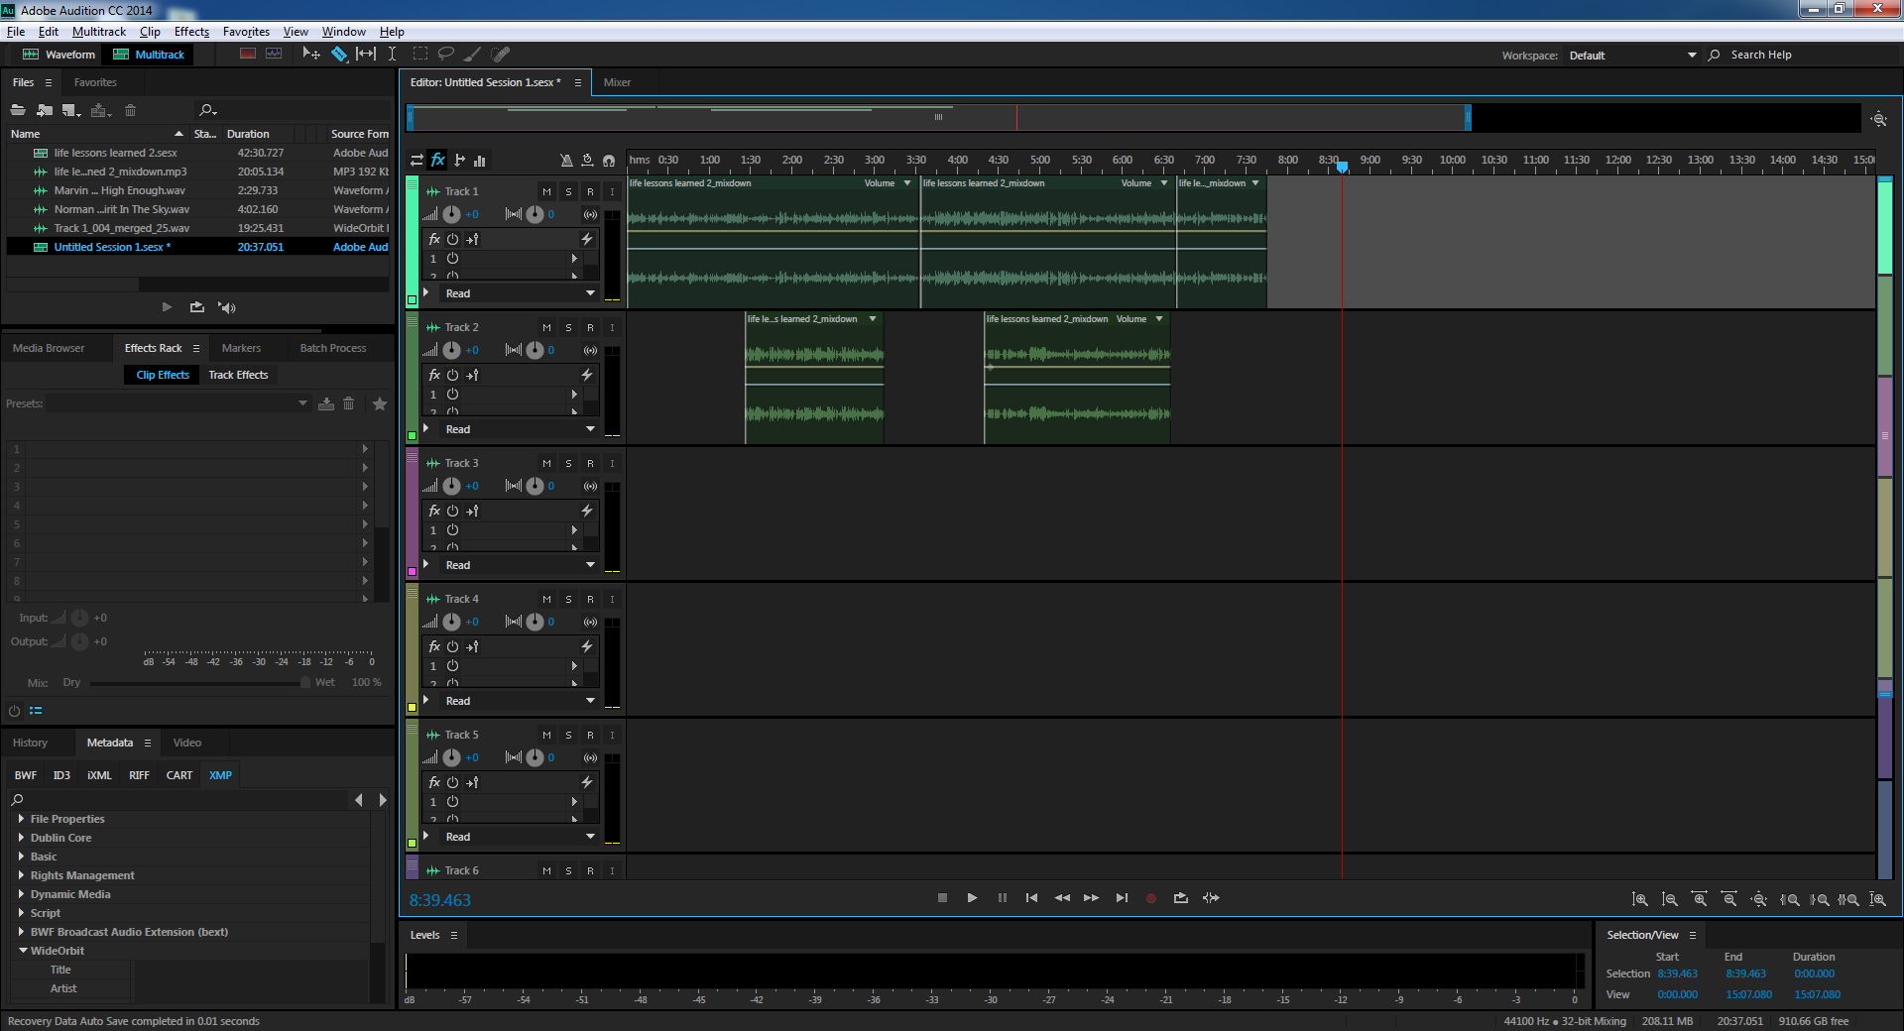

The second screenshot is depicting cutting out the unnecessary parts of the interview and putting the original audio in the top row while the bottom row clips may be deleted or saved for a rainy day. Believe it or not, this is the most time-consuming part of the process.

STEP # 3

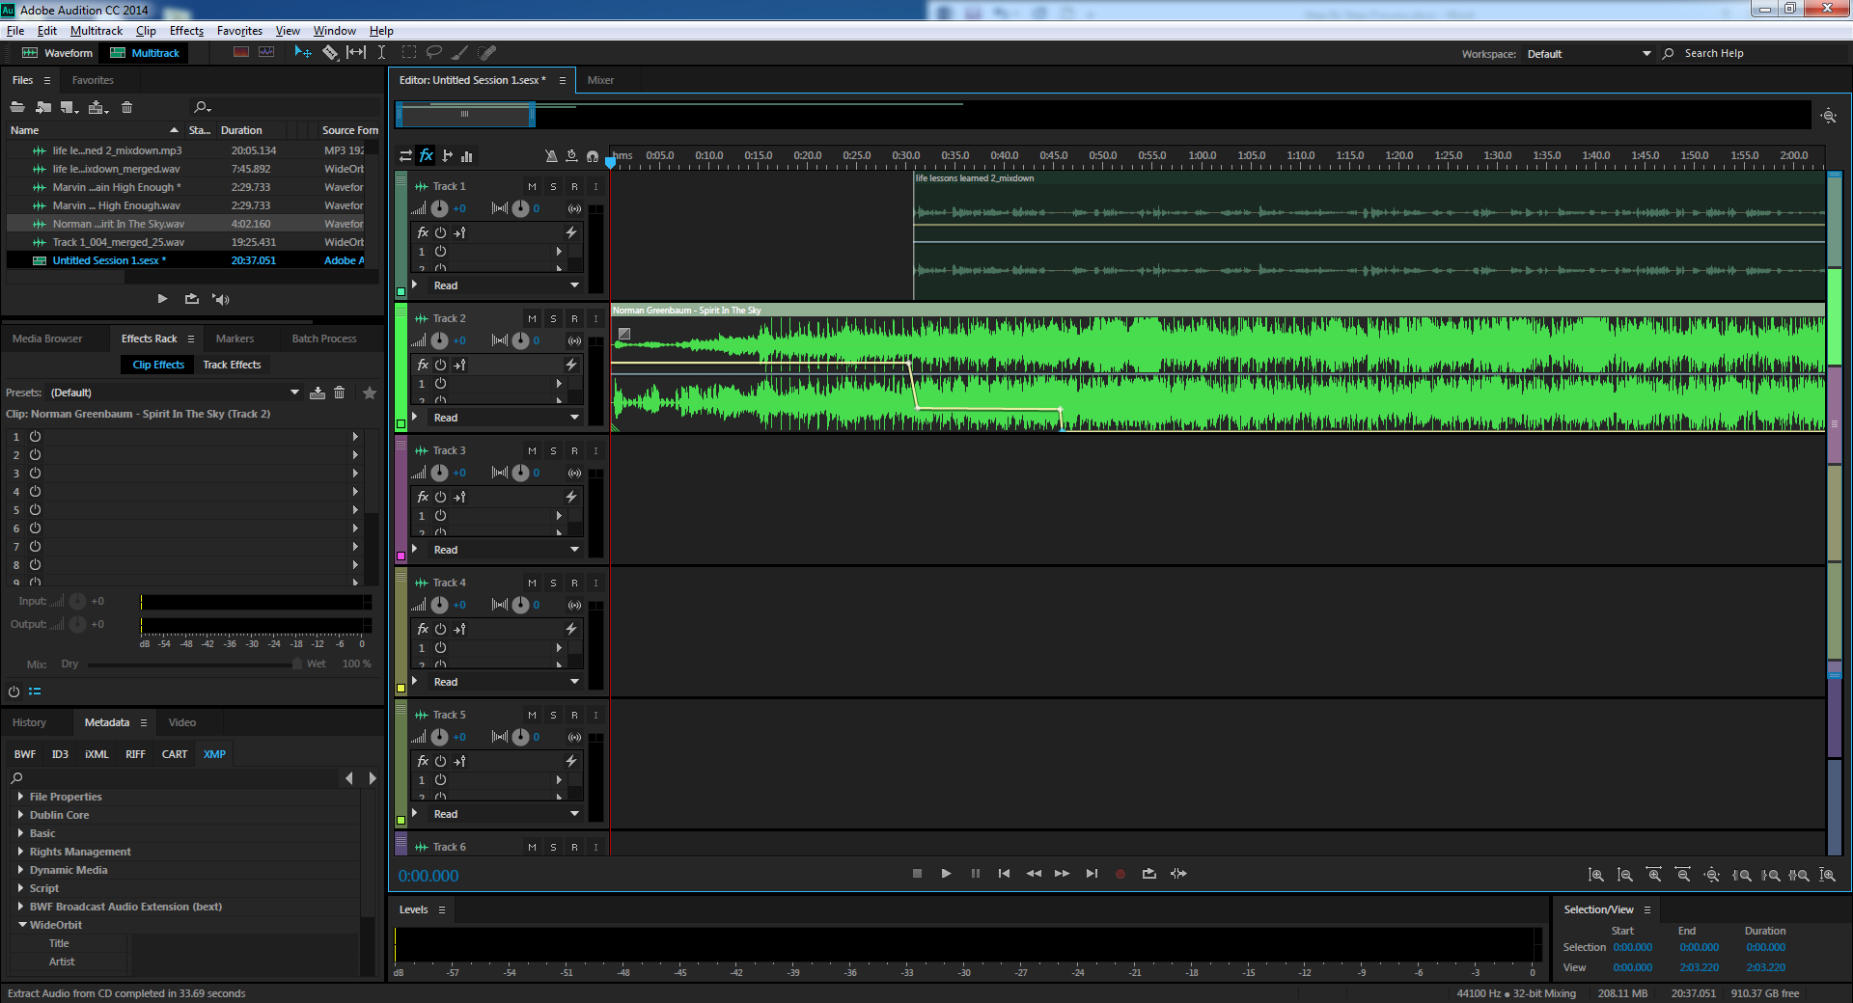

The next step is applying background music. Using background music is designed to enhance rather than distract from the message of the podcast. If you look carefully, you will see a highlighted yellow line within the second row in the multitrack. The yellow line represents the volume of the track. You can control the volume by clicking points along the route dragging it up or down.

STEP # 4

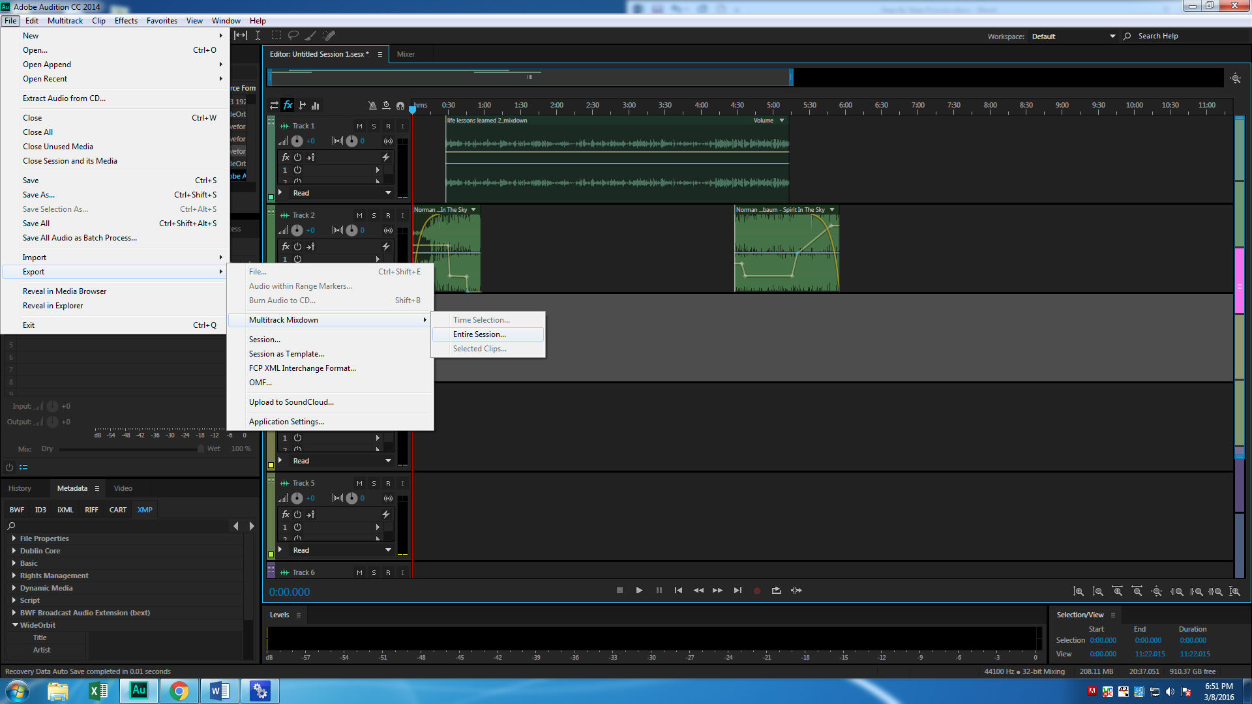

After you are satisfied with the interview and background music, the next step is exporting the podcast. Remember you save the project and then export the File. Select all audio clips, click on File, scroll down to export, follow the path to the words "entire session." Once you export it turn it into an MP3 audio file.

STEP # 5

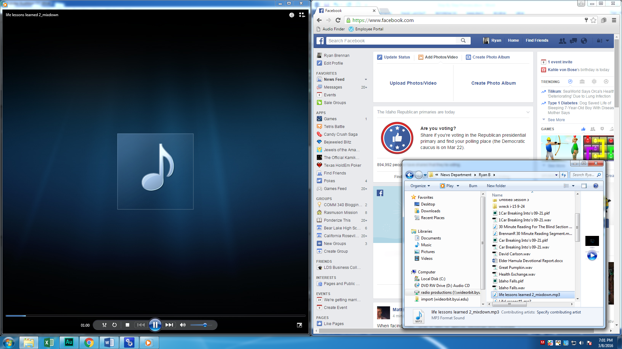

The final step in the process is taking the MP3 file and uploading it to a social media website. The MP3 file on the left is the final product and on the left-hand side is the Facebook website that you can upload your podcast too so your friends, family and the public can listen to it.

**While these five steps may seem simple, there are several smaller steps made to achieve the desired result.

Overview of Matthew Treter

My first interviewee was Matthew Treter. Matthew was born and raised in Wisconsin. He initially studied phycology but changed his major because he knew he would have to deal with a lot of abusive situations. Matthew's current major is Communication, with an emphasis in video production. Eventually, Matthew wants to work for the LDS church producing videos.

“The spirit of the law is the purpose of the rules—once a missionary understands this, then they can love people more effectively.”

Matthew served his mission in the Utah Provo Mission speaking the English language. According to Matthew, Utah has close to 60% LDS members. He says a common misconception is Utah missions aren’t high baptizing. Despite this belief, part-member families provide high percentages of baptisms, which makes Utah missions some of the highest baptizing in the country. His favorite aspect of missionary service was teaching young children the Ten Commandments.

Matthew struggled with understanding strict obedience to mission rules. By living the mission rules to literally, it limited how well he and others could do missionary work. Because being a missionary requires strict adherence to this code of behavior, it's easy to become overly literal. He quickly realized that he was not getting along with his missionary companions because he was too strict, and teaching people about Christ became difficult.

Patiently, Matthew discovered that there are exceptions to the rules--an idea commonly referred to as the spirit of the law. Matthew says the two overarching purposes of the gospel is to love God and love others. The lesson learned—rules can be too literal, and it can get in the way of genuinely loving people.

Overview of Myles Primm

My second interviewee was Myles Prim. Myles says he is from Dallas, Texas, even though he was born in California. He recently got married to a nice girl named Richelle. He was attracted to her because she was kind and well known by many people. Myles respects his wife, and the best part of being married is realizing the potential to do great things.

“Take life as it comes…do not let your circumstances define you.”

Myles served his mission in the Oregon Salem Mission and spoke the Spanish language. One of his favorite words in Spanish is carjo, which means dang you did that. His mission president and trainer helped him learn and grow as a person. Myles loves God and is thankful for Jesus Christ.

While serving his mission, he learned three lessons. People should not take life too seriously because everybody dies; all people struggle, and taking life one day at a time provides for an adventures life.

The main story, Myles told deals primarily with infidelity. His biological father cheated on his mom when he was only nine years old. It took time for him to understand what happened between his mom and dad. Over time, he learned that changing is not being bitter but choosing to do the right thing. Myles learned to take life as it comes and do not let your circumstances define you.

Overview of Lauren Miller

My third interviewee was with Lauren Miller. Lauren was born and raised in Boise, Idaho. He said his parents spoiled him as a child, but he turned out fine. He is majoring in Communication with an emphasis in public relations. Spencer W. Kimball and Elder Henry B. Eyring are his favorite general authorities. He is happily married to a nice girl who was born in Iowa. Lauren likes spicy food. While serving his mission, he participated in a jalapeno pepper eating contest.

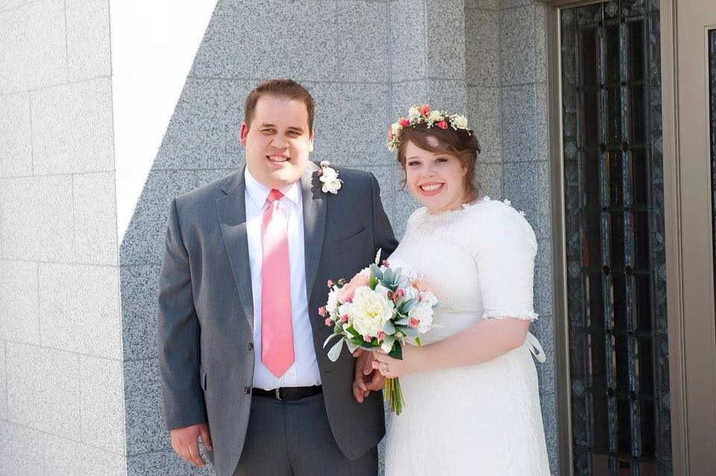
“From this experience, I learned that God is real.”

Lauren served his mission in the Texas Huston Mission speaking the English language. He believes Texas should be its own country. Remembering all the lessons that missionaries taught him, Lauren decided to serve a mission. He also thinks missionary work is like being a ministering home or visiting teacher.

Lauren believes that being married to his wife is pure happiness. He also believes that building a healthy relationship, despite the difficulties, is pure happiness.

Lauren believes in God. He learned that God is real during an experience camping in northern Idaho with his family. As an eight-year-old kid, he was playing next to a fire, tripped, and fell face-first into the giant campfire. His mother, eight months pregnant, quickly ran to the campfire and saved him from being severely burned. Consequently, Lauren learned that God is real and loving.

Conclusion Statement

What did I learn from doing this project? I learned many things from my efforts in completing this project. I learned that people are excited to talk about their life experiences and the lessons they have learned--people enjoy talking about themselves. Persons working in the media exploit this fact to raise awareness of critical societal issues and improve the quality of day to day living.

One of the great takeaways from this project is to be observant. The best piece of advice to those who are looking to improve their interviewing skill is to be attentive. BYU-Idaho professor, Emily Whitlock, Communication 340 – Advanced Media Writing, describes it this way:

- "Four qualities needed to observe well. A good ear for a revealing quote. A sharp eye for descriptive detail. A genuine concern for other people. The ability to listen carefully."

I applied these four characteristics into my interview experience, and it’s resulting in a quality podcast.

After I completed this project, I learned how to use more effectively the Adobe Audition program. The Adobe Audition program is a digital audio workstation from Adobe Systems. According to Google, it features a multitrack, non-destructive mix/edit environment and a destructive-approach waveform editing view. I noticed that during my academic and professional communication-based endeavors, every expert in the industry uses this program. So, it was good that I learned how to use it better.

Also, the podcast is full of spiritual conversation. As such, I am at liberty to expound upon my own religious beliefs. I believe that the greatest wealth found on earth is not physical objects but people. Interviewing people is neat and beneficial because it gives me a greater appreciation for them. It was a pleasant experience to get to know these interviewees on a deeper level. Everyone has a story to tell, and it is our job to listen and learn.

In conclusion, why make a podcast about people telling their stories? The answer is simple; everyone has a story to tell. Listening to the interviewees speak about important societal subjects should inspire the listeners to contemplate their life choices. Furthermore, Life Lesson Learned is a good podcast because it highlights what matters in life—missionary work, college education, career endeavors, and family relationships.
Consequently, I hope that this podcast influences people to make good choices. After all, isn't that what success is—making good choices and improving the quality of our lives?

