To Whom It May Concern:
The purpose of this letter is to offer a general recommendation for Ryan Brennan to prospective employers who might be interested in utilizing him within their organizations. Although I cannot comment specifically on fit within a specific company, I can tell you what I perceive to be Ryan’s general strengths that would make him an asset in a variety of different work environments.
First, I would argue that Ryan has very good critical thinking, analytical, research, and writing skills. When he took my graduate level Qualitative Research Methods class, he turned in work that was generally superior to many of his classmates. I could always tell he paid great attention to detail and worked hard to make strong, well-developed arguments in his assignments. His response papers to weekly readings showed a real effort to digest the material on a deeper level and his final paper provided evidence that he understood the structure and rigors of academic research. His evaluation of a “mock” qualitative interview was impressive enough that I still use it as a sample of good work for other students.
Second, I would suggest that Ryan has a drive unlike most students we’ve had come through our graduate program. I’ve been teaching in our Master of Arts in Professional Communication (MAPC) program at SUU since its inception in 2005 and I would place Ryan in the top 10% in terms of sheer determination and focus. If you need something done well, I’m sure you could count on him to do it. Because Ryan was an online student, I didn’t have quite as many interpersonal interactions with him as I may have with some of our face-to-face students. However, I interacted with him frequently during my class through email and we’ve exchanged messages from time to time since his graduation last year. He is an amiable and pleasant young man. I look forward to seeing what he might do in his future endeavors and would encourage anyone looking for someone skilled and dependable to give him a second look when trying to fill important positions within their organizations.
If you have any additional questions for me, I can be reached by phone at (435) 586-7874 or by email at stein@suu.edu.
Sincerely,
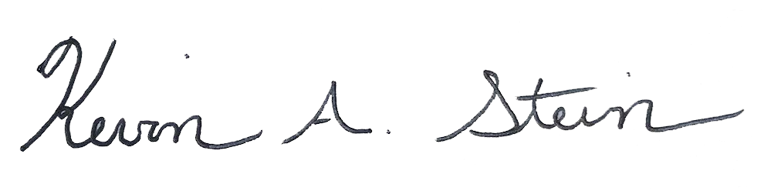
Kevin A. Stein, Ph.D.
Professor of Communication/MAPC Director
Southern Utah University
351 W. University Blvd., EVT 213B
Cedar City, UT 84720
(435) 586-7874

